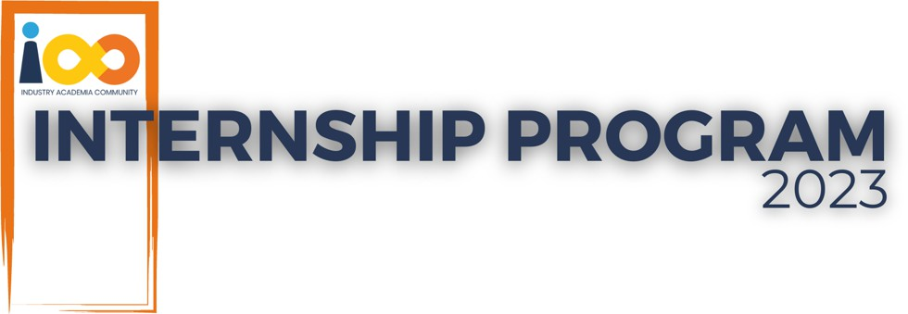

PROJECT REPORT

Data Analytics

Students' Success Equation: Cracking the Variables

|  |  |  |  |
| --- | --- | --- | --- |
| **Created By:** | SUSHANT AGGARWAL | **Approved By:** | HARSHADA TOPALE |
| **Created On:** | 04-12-2024 | **Approved On:** | 17-08-2024 |

Page left blank intentionally



  2

 2   2



* 1. Background 2
  2. Stakeholders 2
  3. Objectives 2

 2



* 1. Considerations & Assumption 3
  2. Approach 3
  3. Activities 3

 3   3   4



* 1. Appendix A – Title 4



* This template and the subsequent document created using this template is a confidential document and is the intellectual property of Cloud Counselage Pvt. Ltd. Circulating it outside of the organisation without the consent of Cloud Counselage Pvt. Ltd. is the breach of company policies and will lead to legal actions
* This template is a guideline document to communicate the implementation of design ideas and the results of the work to the stakeholders.
* The  by relevant text
* Please        between the inequality (< >).

This is done to help you notice the text to be changed/replaced

* The text in *italics*highlighted in grey is just for reference and should be removed after adding the relevant text



|  |  |  |  |
| --- | --- | --- | --- |
|  | Students’ Success Equation: Cracking the Variables | | |
|  | Tushar Topale | | |
|  | Harshada Topale | | |
|  | 07-09-2024 |  | 05-12-2024 |





The project revolutionizes talent evaluation through advanced data analytics, comprehensively assessing student potential. By developing a more adaptive and responsive professional development framework, it seamlessly connects academic knowledge with real- world professional skills, transforming how we understand and nurture emerging talent.

The need for this project was realised to optimize the intern program and maximize its impact. By understanding the factors that contribute to intern success, we can implement targeted interventions to improve performance, skill development, and overall satisfaction. Key Deliverables:

1. Comprehensive data insights on intern performance by cleaning data
2. Correlation analysis between academic and professional indicators through statistical analysis and visualization
3. Strategic recommendations for skill development
4. Develop predictive models to forecast intern performance using predictive metrics.



* + Enhanced student career preparation
  + More targeted educational support
  + Improved talent identification for employers
  + Data-Driven culture





Millions of students apply for internships/jobs every year, resumes play an important role in playing the first impression. The recruiters spend a max of 2-3 minutes reviewing a resume after it landed in their mailbox or Job board, ATS application: Surprisingly more than

70% of resumes get rejected in the initial screening.



This project involves multiple stakeholders, each with a vested interest in the outcomes and insights derived from a comprehensive analysis of student interns. Key stakeholders include:

1. Educational Institutions: Universities, colleges, and vocational schools offering internship programs as part of their curriculum. These institutions aim to enhance student learning and career readiness by improving internship program offerings and providing better support.
2. Employers: Companies and organizations hosting student interns. By optimizing internship programs, attracting top talent, and fostering a pipeline of skilled professionals, employers can effectively mentor and integrate interns into their workforce.
3. Students: Interns themselves are vital stakeholders. By understanding the factors contributing to intern success, students can make informed decisions about their internship opportunities and maximize their learning and career development.
4. Career Services Offices: These offices within educational institutions provide support to students in securing internship placements and preparing for their professional careers. By ensuring students have access to high-quality internship opportunities and resources, career services offices contribute to student success in internships and future careers.
5. Community Partners: Non-Profit organizations, community groups, and other entities collaborating with educational institutions and employers to provide internship opportunities are also the stakeholders in the project. They are interested in ensuring that the internship aligns with community needs and provides meaningful experience for students.



Conduct a comprehensive analysis of student interns to gain insights about the relationship between their academic performance, event participation, career aspiration and factors influencing their success.





These conventions are all about the positions of line breaks, how many characters should go on a line, and everything in between.



Considerations:

* +  The data we collect must be accurate, complete, and representative of all students. If the data is flawed, our analysis will be flawed too.
  +   We need to use the right statistical methods to draw accurate conclusions. We must consider all factors that could influence the results.
  + We must protect students' privacy by keeping their information confidential.
  +  Different fields of study, internship programs, and schools can have different impacts on students. We need to account for these differences.

Assumptions:

* +     We assume we can measure skills like problem-solving and teamwork, even though they can be hard to quantify.
  +   We assume that certain actions (like attending workshops) directly lead to specific outcomes (like getting a good job).
  +  We assume that what we learn from this study can apply to all students, but different students may have different experiences.



* + - Problem Definition: The first step was to clearly define the goals and scope of the project. This involved identifying the specific research questions, such as understanding the relationship between students' academic performance, participation in events, career aspirations, and success in internships.
    - Literature Review: Conducting a thorough review of existing research, theories, and best practices related to student internships, academic performance, and

career development was essential. This helped inform the project's methodology, identify relevant variables, and build on prior knowledge.

* + - Data Collection: A systematic approach was used to gather relevant data from various sources, including educational institutions, employers, and the student

interns themselves. This involved designing surveys, interviews, or accessing existing databases to collect both quantitative and qualitative data on factors influencing internship success.

* + - Data Analysis: Advanced analytical techniques, such as statistical analysis, regression modeling, and qualitative coding, were employed to explore the relationships and patterns within the dataset. This step focused on identifying

correlations, trends, and insights that could help understand the dynamics of internship experiences and their impact on students' career trajectories.

* + - Interpretation and Synthesis: The findings from the data analysis were interpreted and synthesized to draw meaningful conclusions and actionable

insights. This involved triangulating quantitative and qualitative evidence, contextualizing results within theoretical frameworks, and making connections between the variables to answer the research questions.

* + - Recommendations and Implications: Based on the synthesized findings, the project provided actionable recommendations to address the identified

challenges and leverage opportunities within the internship ecosystem. These recommendations may include strategies for educational institutions, guidelines for employers, or policy suggestions to improve internship accessibility and quality.

* + - Iteration and Validation: The structured approach allowed for iterative refinement of the analysis and recommendations based on feedback, peer review, and validation from stakeholders. This iterative process ensured the robustness and credibility of the findings and recommendations, enhancing their applicability and impact.



The key activities involved in delivering this project:



* + - Problem Definition Clearly defined the problem statement and objectives of the project.
    - Stakeholder Identification Identified and engaged key stakeholders (educational institutions, employers, students, and career services offices).
    - Scope Definition Determined the scope of the project, including the data to be analyzed, the analysis techniques to be employed, and the desired outcomes.
    - Project Planning Created a detailed project plan outlining tasks, timelines, and resource allocation.



* + - Data Cleaning Cleaned and preprocessed the data to ensure accuracy and consistency, addressing missing values, outliers, and inconsistencies.





* + - Data Exploration Explored the data using descriptive statistics and visualizations to gain insights into the distribution, relationships, and trends within the data.



* + - Correlation Analysis Identified relationships between variables to understand how factors like academic performance, event participation, and career aspirations influence each other.
    - Regression Analysis Built regression models to predict student performance or identify key factors contributing to success.
    - Hypothesis Testing Conducted statistical tests to verify hypotheses about the relationships between variables.



* + - Data Interpretation Interpreted the results of the analysis to draw meaningful insights.
    - Recommendation Development Formulated data-driven recommendations for improving internship programs, student development, and employer practices.
    - Report Preparation Prepared a comprehensive report summarizing the project methodology, findings, and recommendations.
    - Presentation Development Created presentations to communicate the findings and recommendations to stakeholders effectively.



* + - Project Review Conducted a final review of the project, assessing its success against the defined objectives.
    - Lessons Learned Identified lessons learned for future projects.
    - Documentation Archived project documentation for future reference.





Targeted Output:

 The project plan aimed to deliver a detailed report

summarizing the analysis of student interns, including insights into the relationship between academic performance, event participation, career aspirations, and factors influencing success.

Achieved Output:

 Due to limited time and resources, we focused on creating

an executive summary report. This report highlights the key findings and recommendations from our analysis. Although we originally planned to produce a full comprehensive report, prioritizing the executive summary allowed us to share crucial insights with stakeholders promptly.





The project aimed to delve into the complex relationship between academic performance, event participation, career aspirations, and success factors among student interns. By analyzing a comprehensive dataset, we sought to uncover valuable insights that could inform strategies for enhancing internship programs and student development.

The findings from this research serve as a springboard for further exploration and innovation. As we continue to refine our approach to student development, it is our hope that this project will inspire others to embrace a data-driven, holistic mindset - one that celebrates the multifaceted nature of human potential and fosters an educational ecosystem truly aligned with the demands of the modern workforce.

Through rigorous data analysis, we identified several key findings:

* + -      A strong correlation was

observed between academic performance and career aspirations, suggesting

that high-achieving students tend to have more ambitious career goals.

* + -      Active participation in events and

workshops was positively linked to the development of soft skills such as

communication, teamwork, and leadership.

* + -    Students with dedicated mentors showed higher levels of satisfaction and reported greater professional growth.

Ultimately, this project represents a significant stride towards bridging the gap between scholastic performance and real-world success. By empowering students with a clearer understanding of their capabilities and potential, while equipping educational and corporate stakeholders with evidence-based strategies, we can cultivate a more dynamic, responsive, and equitable system for launching young professionals into rewarding careers.





|  |  |  |
| --- | --- | --- |
|  |  |  |
| Project Initiation | 07-09-2024 | 05-12-2024 |
| Literature Review | 10-09-2024 | 15-09-2024 |
| Data Collection | 20-09-2024 | 20-10-2024 |
| Data Analysis | 22-10-2024 | 12-11-2024 |
| Report Writing | 20-11-2024 | 01-12-2024 |
| Presentation | 03-12-2024 | 05-12-2024 |